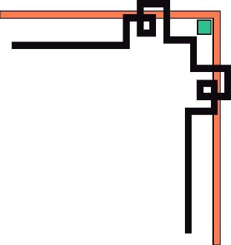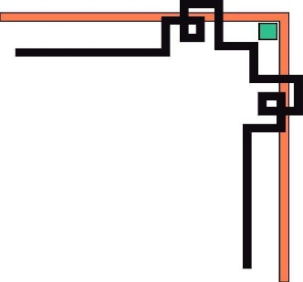

**HO CHI MINH UNIVERSITY OF TECHNOLOGY AND EDUCATION**

**FACULTY FOR HIGH QUALITY TRAINING**

**🕯✡🕮🕮✡🕯**



**PROJECT**

**IT PROJECT**

**STUDENT MANAGEMENT**

**Lecturer: Mr. Le Van Vinh**

**Class: PROJ215879E**

**Group: 10**

**Ho Chi Minh, November 15th 2022**

**MEMBER OF TEAM**

|  |  |  |
| --- | --- | --- |
| **No.** | **Name** | **ID** |
| 1 | Lê Tấn Lộc | 20110379 |
| 2 | Nguyễn Minh Nhật | 20110430 |

**EVALUATION AND SCORE**

**EVALUATION:**

…………………………………………………………………………………………………

…………………………………………………………………………………………………

…………………………………………………………………………………………………

…………………………………………………………………………………………………

…………………………………………………………………………………………………

…………………………………………………………………………………………………

…………………………………………………………………………………………………

…………………………………………………………………………………………………

…………………………………………………………………………………………………

…………………………………………………………………………………………………

…………………………………………………………………………………………………

…………………………………………………………………………………………………

…………………………………………………………………………………………………

…………………………………………………………………………………………………

…………………………………………………………………………………………………

**SCORE**:………………………

**TABLE OF CONTENTS**

PART 1. INTRODUCTION TO THE APPLICATION 6

PART 2. DESIGN INTERFACE OF APPLICATION 7

2.1. Account 7

2.2. Form StudentApp 10

2.3. StudentForm 10

2.4. CourseForm 13

2.5. ScoreForm 16

2.6. Result 17

2.7. HR 19

2.8. Contact 20

2.9. Output 23

PART 3. DATABASE DIAGRAMS 29

3.1. Database datagram model 29

3.2. Database table 29

3.2.1. Table Student 29

3.2.2. Table Course 30

3.2.3. Table Score 30

3.2.4. Table Login 31

3.2.5. Table HumanResource 31

3.2.6. Table MyContact 32

3.2.7. Table MyGroup 32

PART 4. SOFTWARE ARCHITECTURE 34

4.1. Database Tier: Dbmain 34

4.2. Business Tier 35

PART 5. ASSESSMENT OF THE PROGRAM 47

5.1. Advantage 47

5.2. Disadvantage 47

PART 6. OVERALL 48

INTRODUCTION TO THE APPLICATION

Nowadays, there are still a few schools that use handwritten documents to manage students, which will have many disadvantages. This will make the management of the school's student system difficult in updating, editing, preserving, archiving and other management purposes; This type of management will take a lot of time but the efficiency is quite poor. Therefore, my group decided to choose this topic and implemented the "Student Management" program using ADO.NET of C#

DESIGN INTERFACE OF APPLICATION

Account

**Form Login**

That is the beginning form of the application. To use the application, we need to use this form to create or log in the account to use the program.

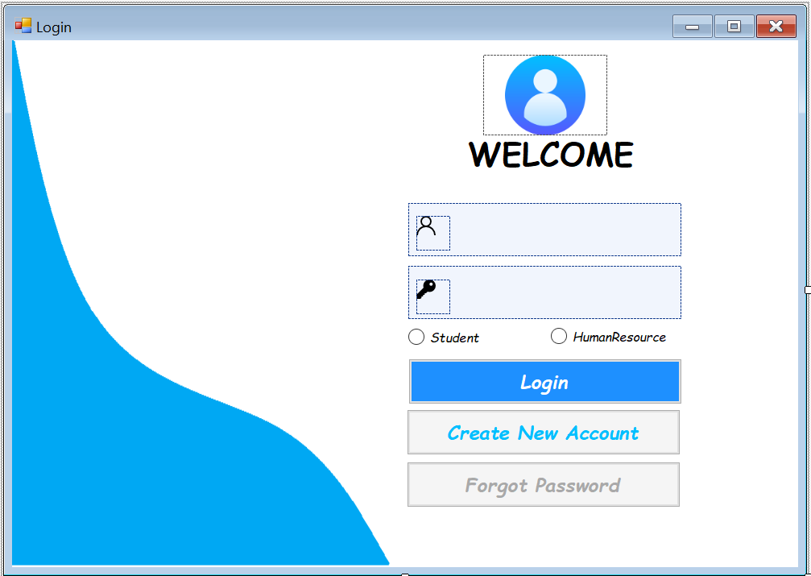

**Form CreateAccount**

This form is connected to form Login, this form is used to create new account for the user to use the program

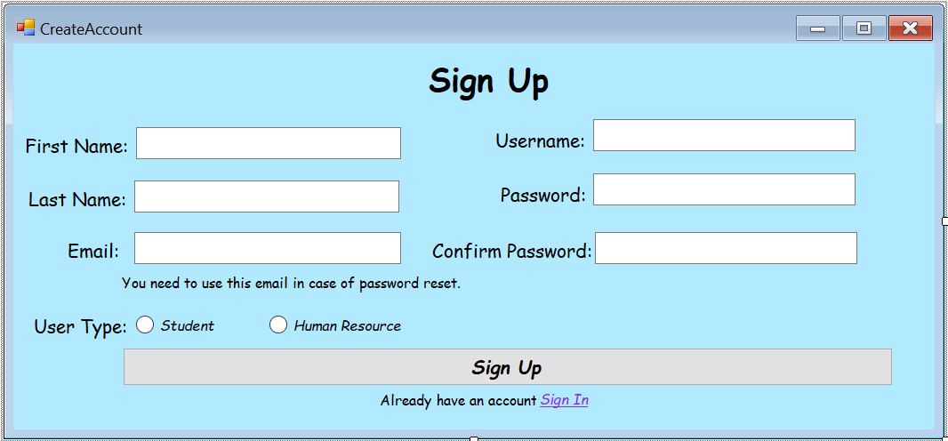

**Form ForgotPass**

This form is connected to form Login, when the user forgot the password of their account, this form will help them to create a new password with their email address

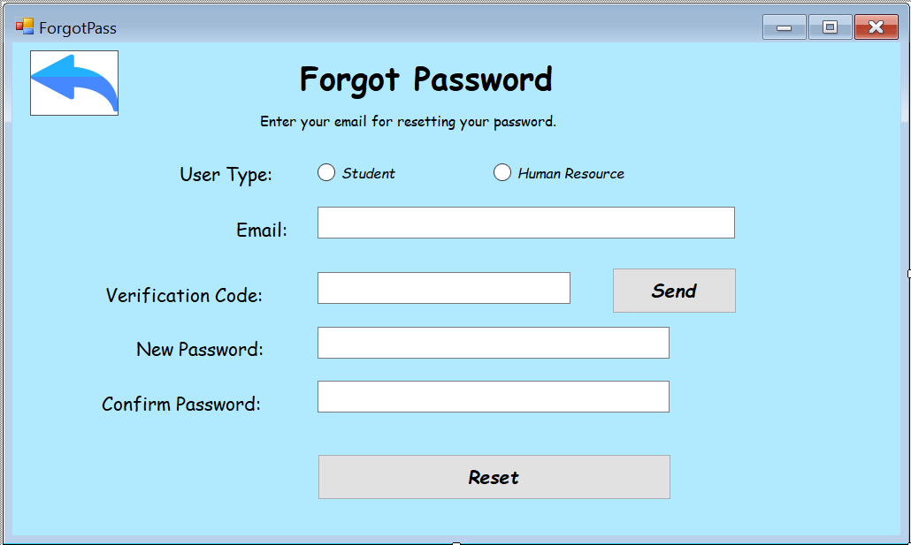

**Form Loading and form LoadingHr**

This is 2 forms are used for decorative purposes, when we login the account, those forms will appear in a moment

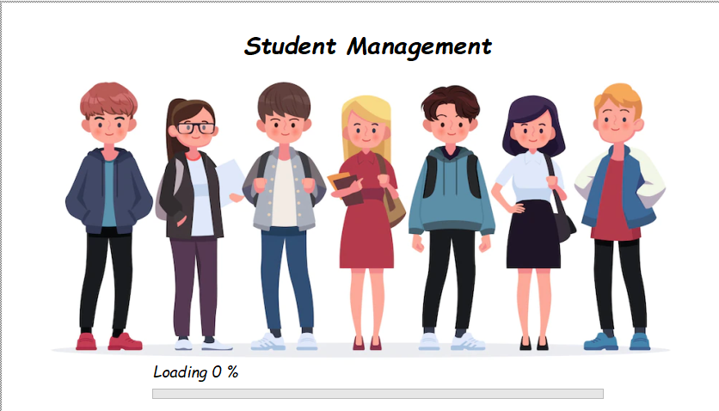

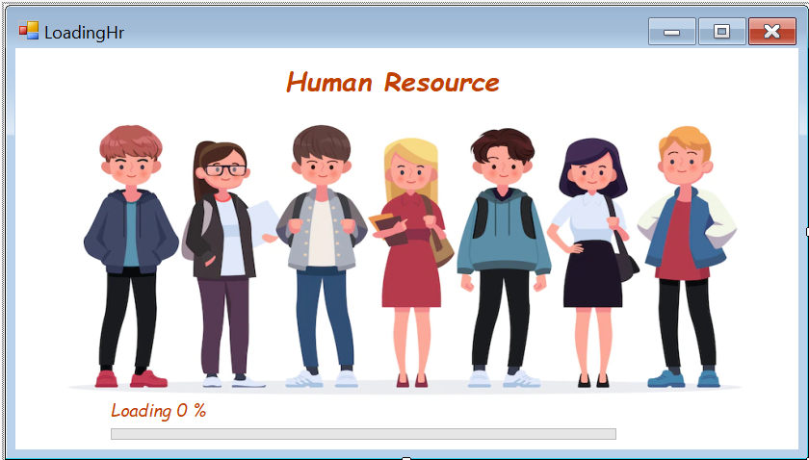

Form StudentApp

When we login the account, if we choose the permission is student, it will connect to this form. This is the main form which is used to manage all the main information of the course of each student

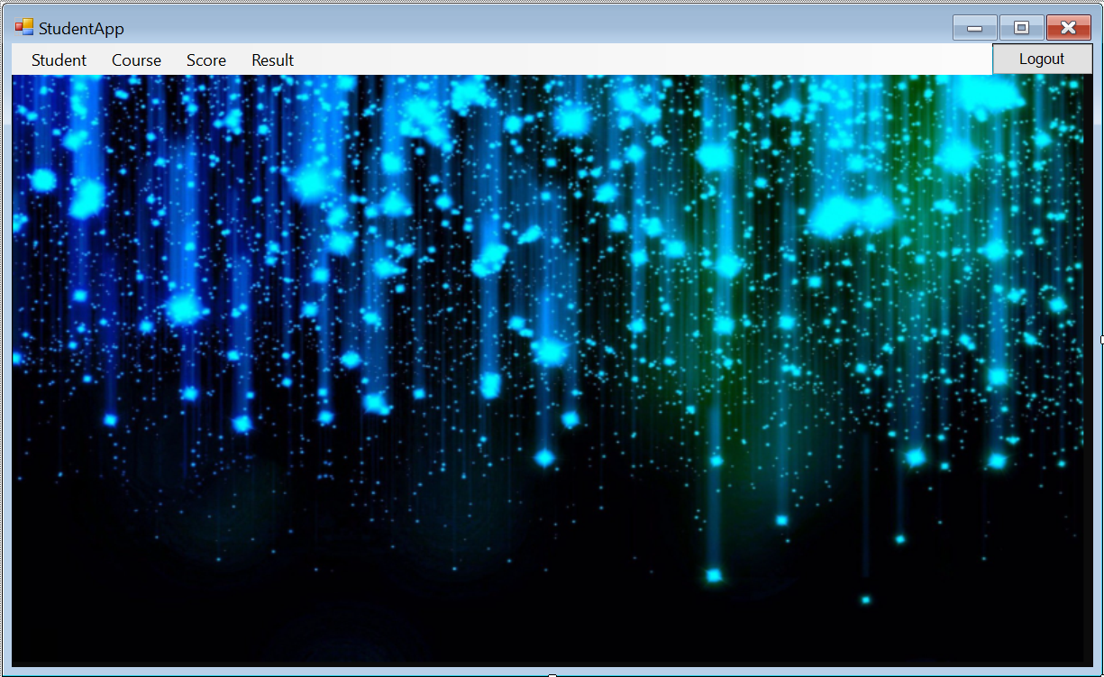

In this form, there are some MenuStrip to connect with others management form such as: StudentForm, CousrseForm, ScoreForm and Result

StudentForm

**ManageStudent**

This form is used to manage the main information of students such as: student id, first name, last name, birthday, gender, phone, email, address, picture. In this form, we can do some functions like add student, remove student, edit information for student, search student, update the information for student.

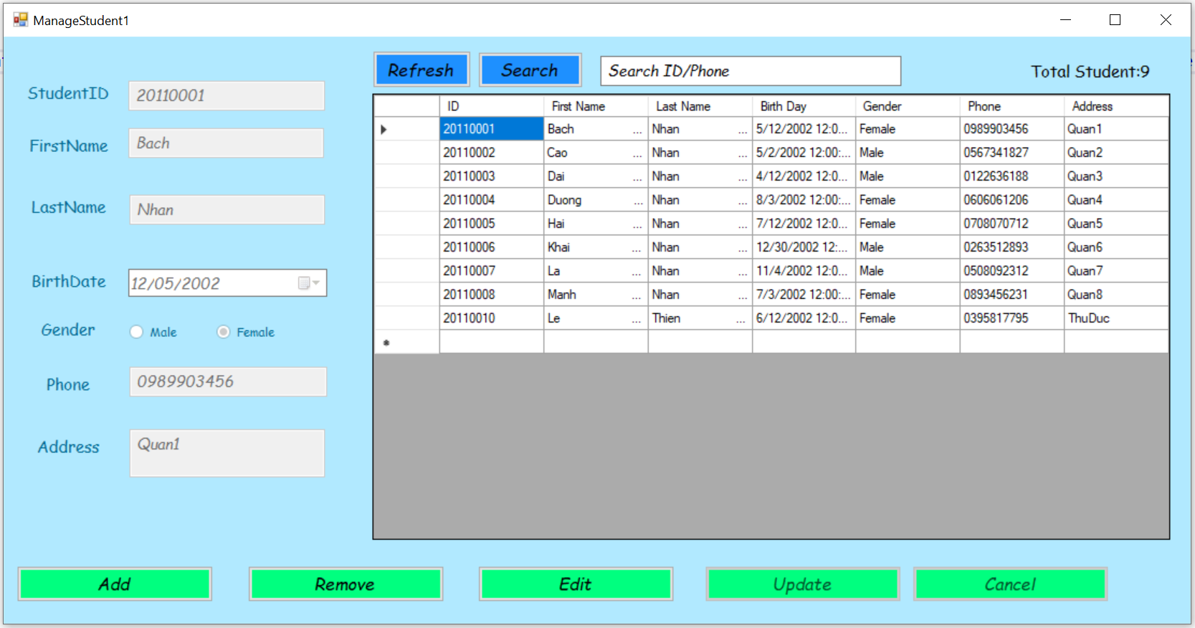

**Form StatisticGender**

This form is used to list the gender of all students in student list

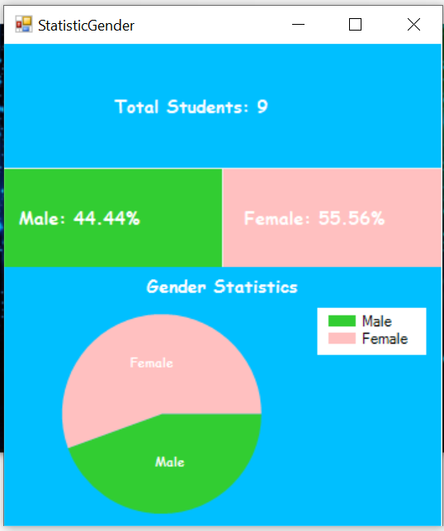

**Form PrintStudent**

This form is used to print the information of student into file word or excel, this form also can find students by some criteria

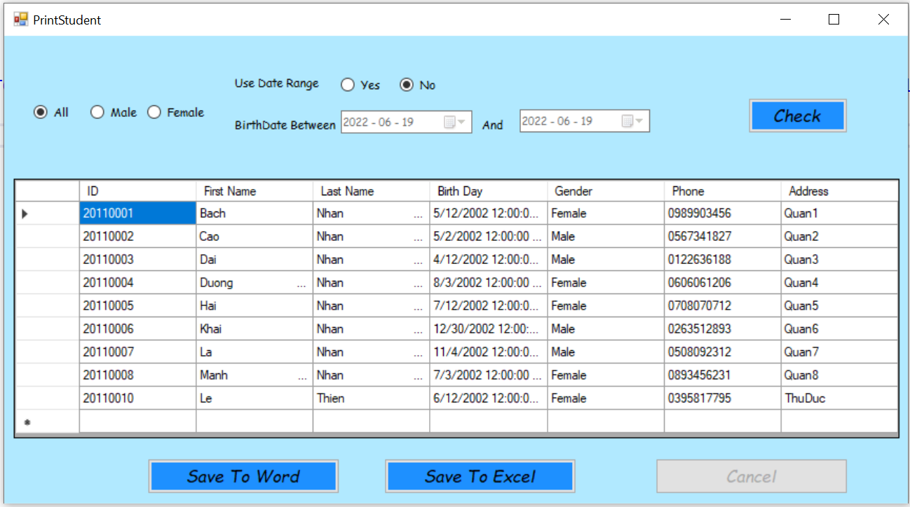

CourseForm

**ManageCourse**

This form is connected to form StudentApp, this form is used to manage some information of courses

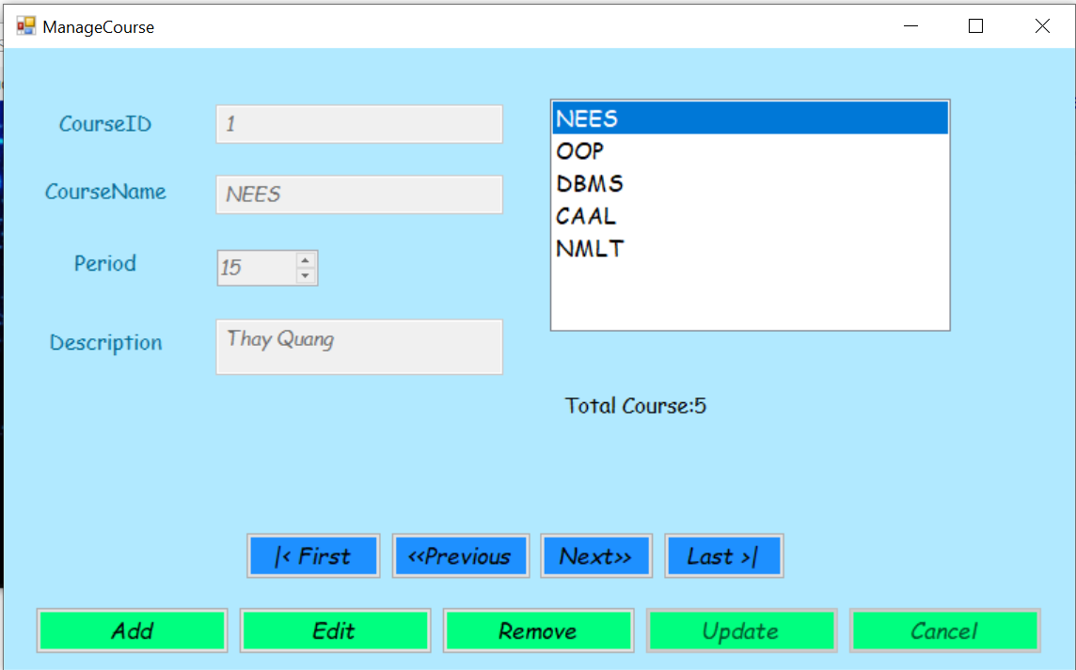

In this form, we also can add course, remove course, edit or update the information of course

**Form ListStudentByCourse**

This form is used to list the students by course that they study in the semester

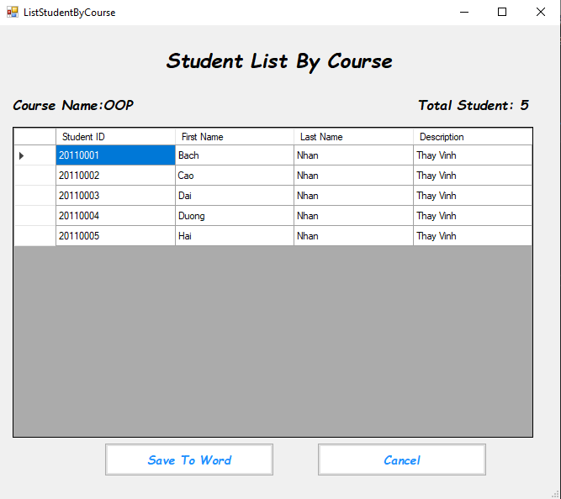

**Form PrintCourse**

This form is used to print the information of course into file word, excel or pdf

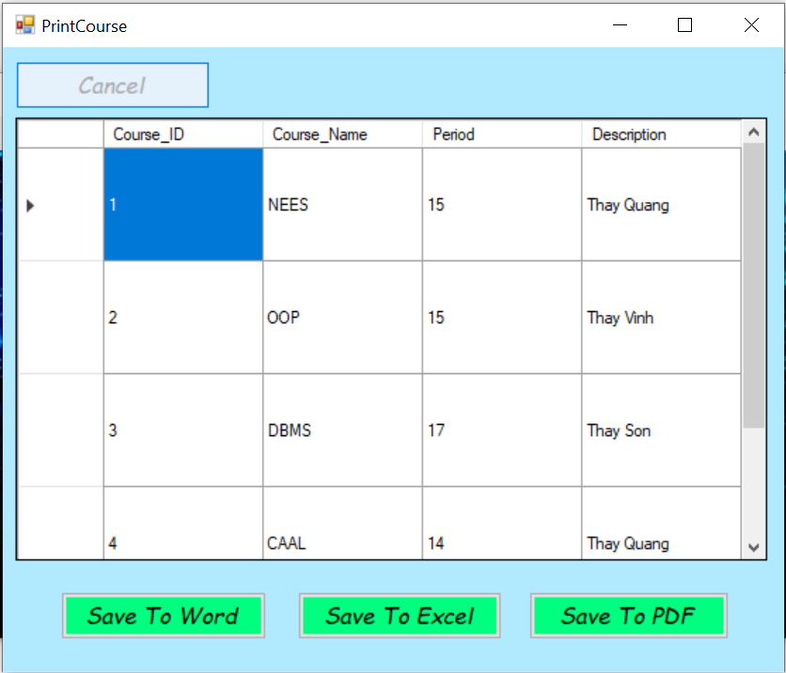

ScoreForm

**ManageScore**

This form is connected to form StudentApp, this form is used to manage some information about the scores of students

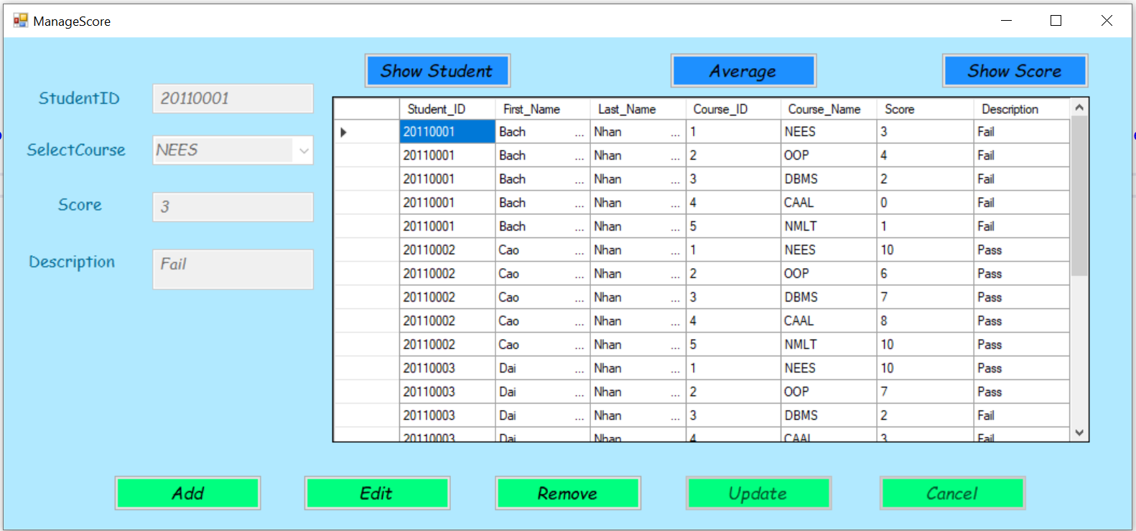

In this form, we also can add score, remove score, edit or update the information about the score of the course

**Form AverageScore**

This form is used to show the average score of all subjects for each student

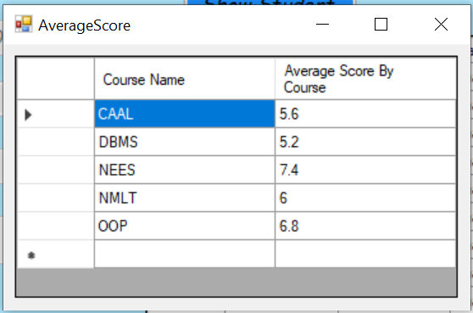

**Form PrintScore**

This form is used to print the information of course into file word, excel or pdf

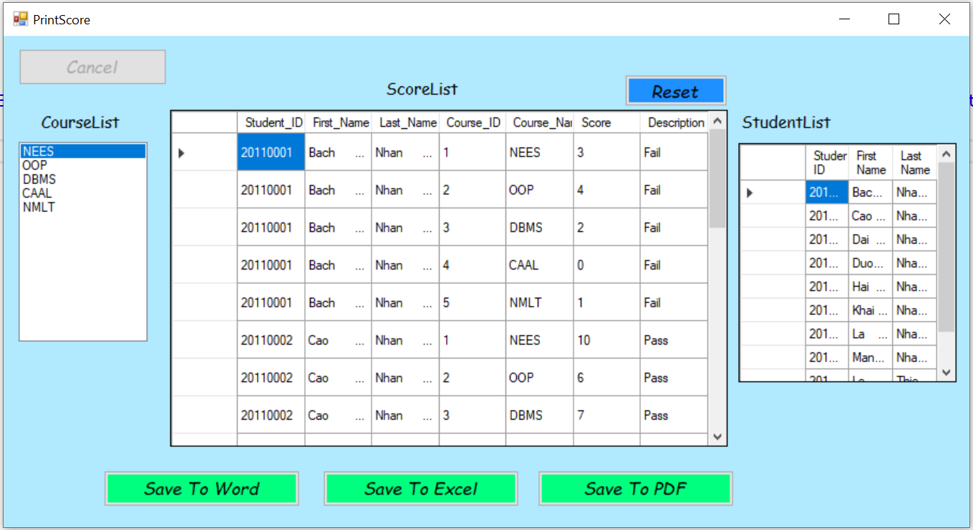

Result

**AverageScoreResult**

This form is used to show all information about the courses of each student to screen, for example the name of the courses that a certain student has studied, the result of some course that a certain student has studied,… We also can search the result of a student by her or his Student ID, First Name or Last Name

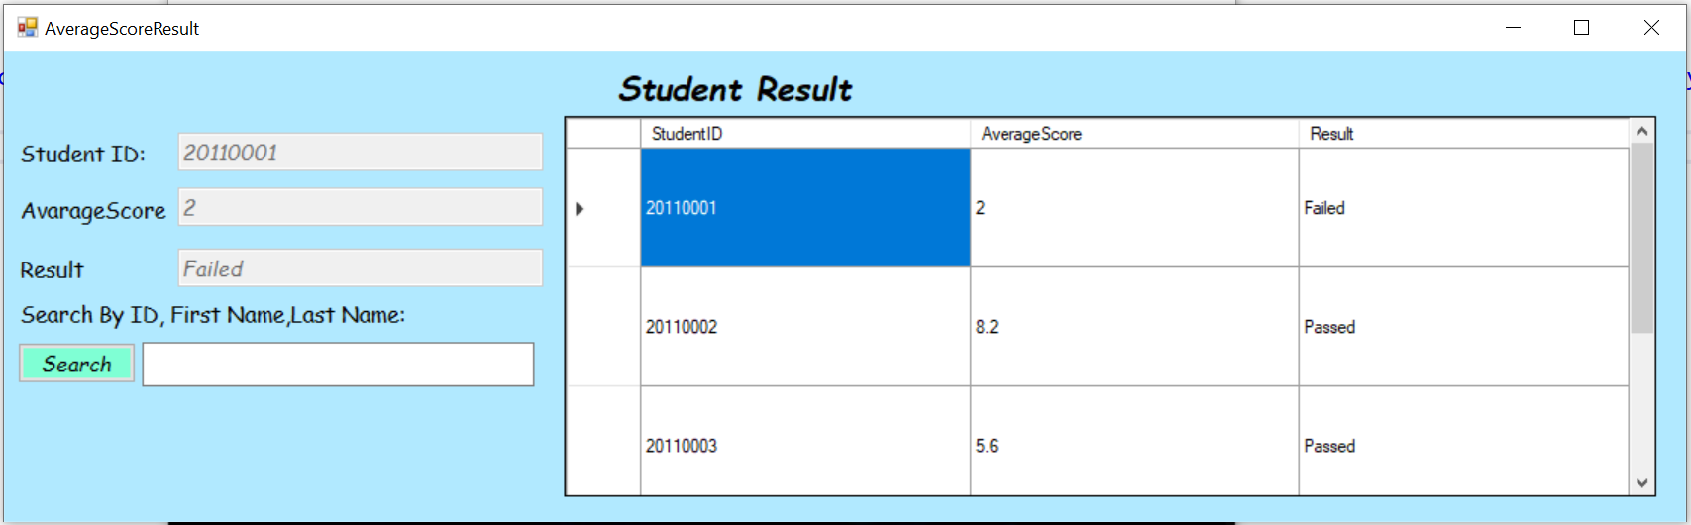

**Form StatisticResult**

This form is used to list the result of all students in the student list, it can also show the pass-to-fail ratio or the percentage of the results

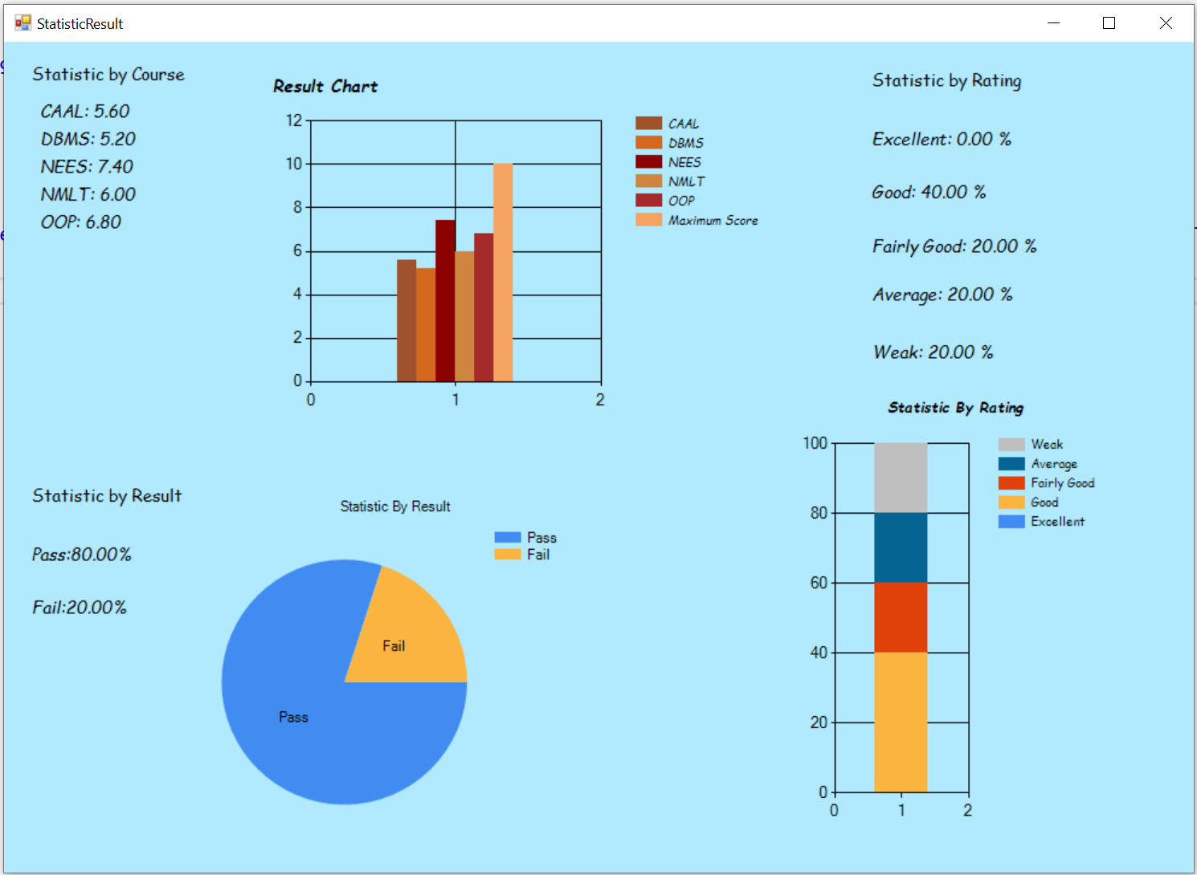

HR

**HRmain**

When we login the account, if we choose the permission is HumanResource, it will connect to this form. This is the main form which is used to manage the personal information of student

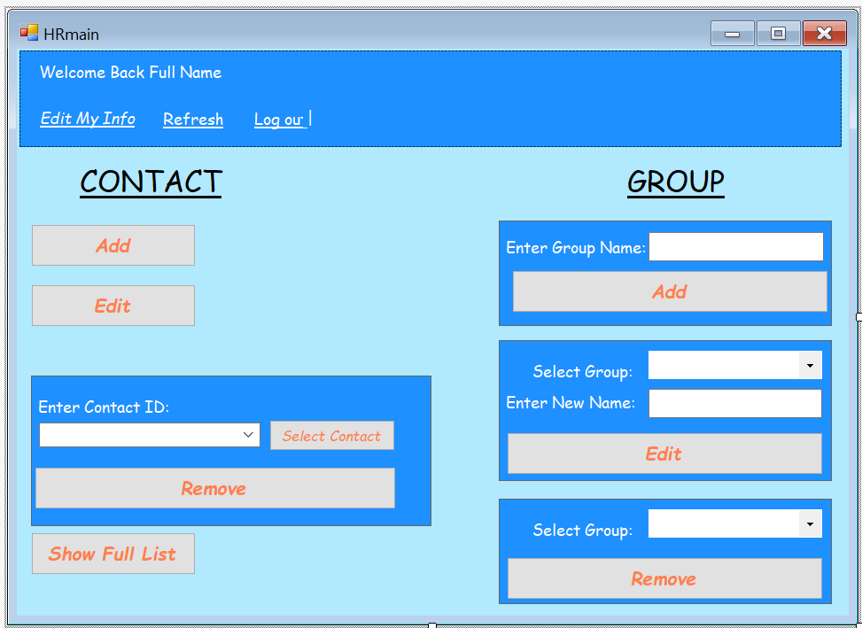

In this form, we could manage 2 part is Contact (the information about how to contact with the teacher such as: phone, email, address,…) and Group (the information about faculty that the student has studied)

**Form EditInfor**

This form is used to edit the information of the account that we are using, for example: change the name, change the email, change the password of the account

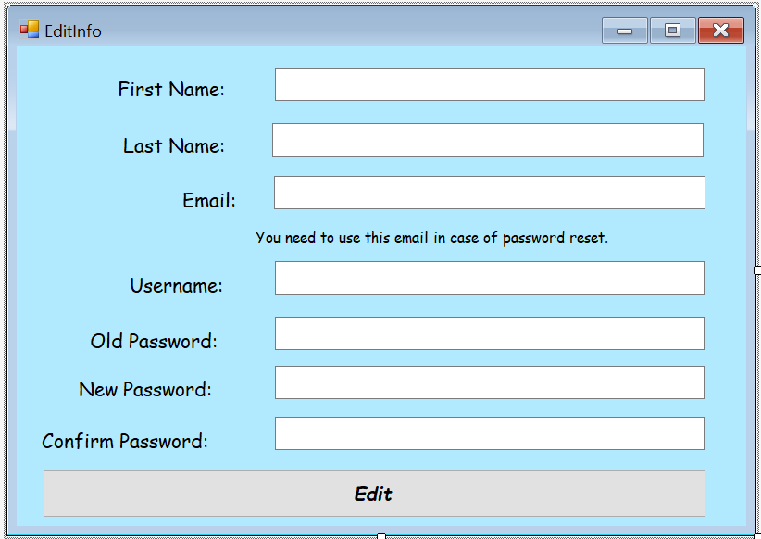

Contact

**AddContact**

This form is used to add the information about the way to contact with teacher

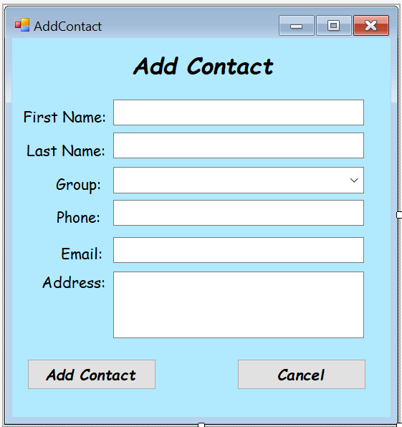

**Form EditContact**

This form is used to change the information about the contact with a teacher

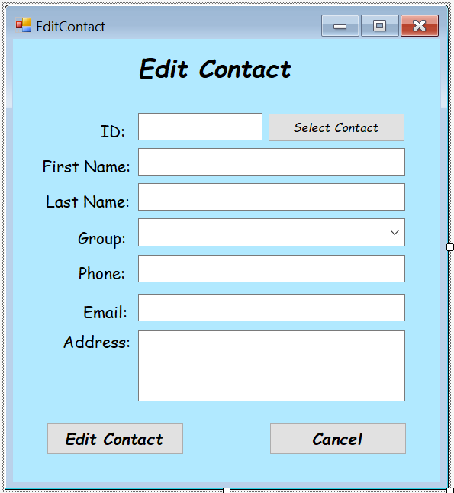

**Form SelectContact**

This form is used to support for the form EditContact, it will help us select the information about the contact of teacher that we want to update the information

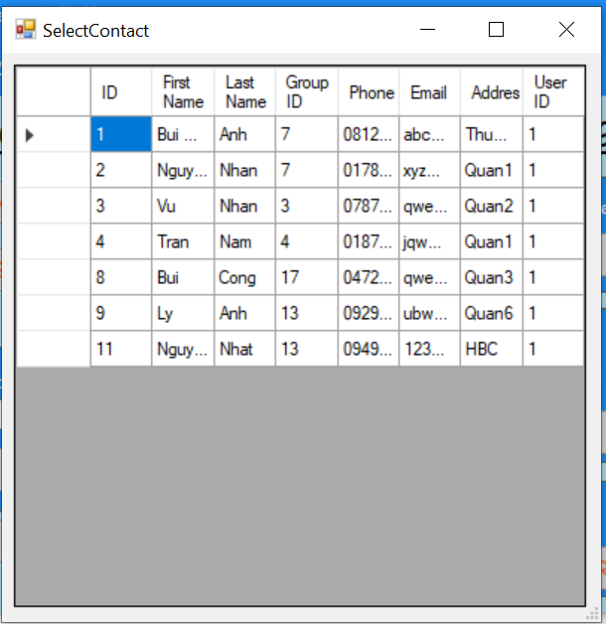

**Form ShowFullContact**

This form is used to show all the information about the contact of all teacher in the list. We also can find the information about the contact of the teacher by using his or her address

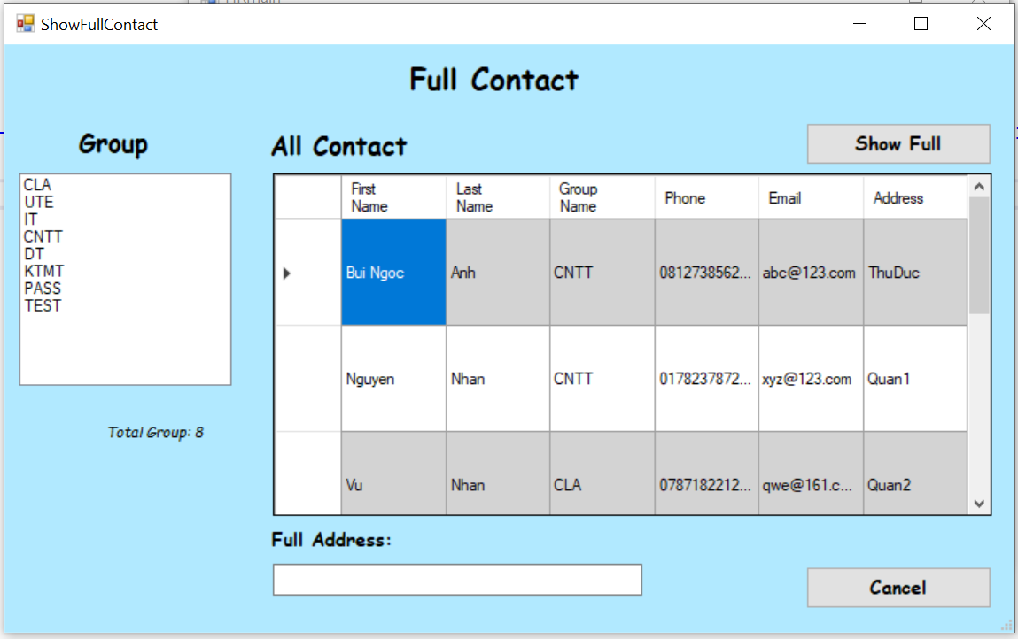

Output

**PrintStudent**

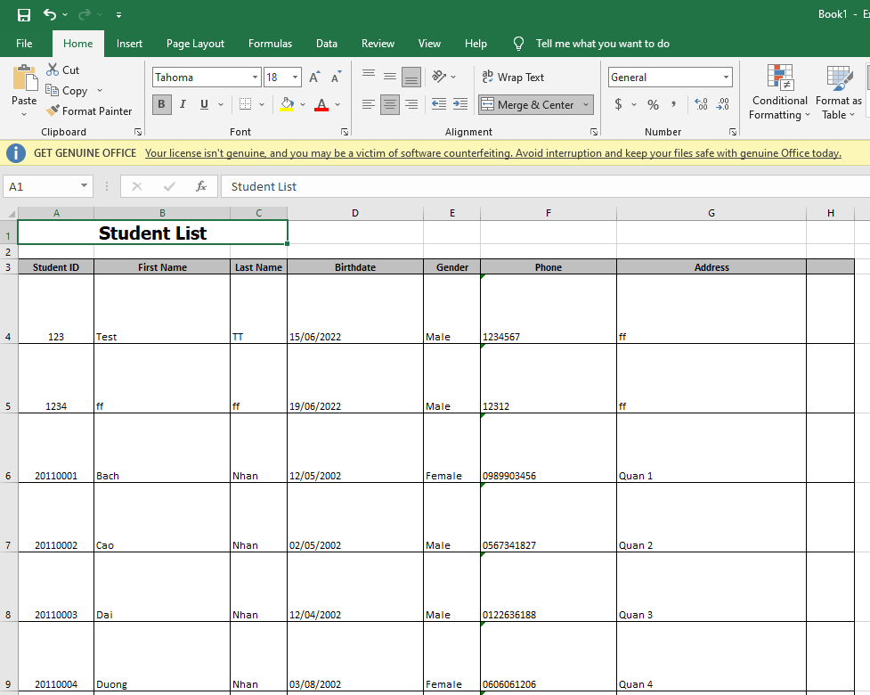

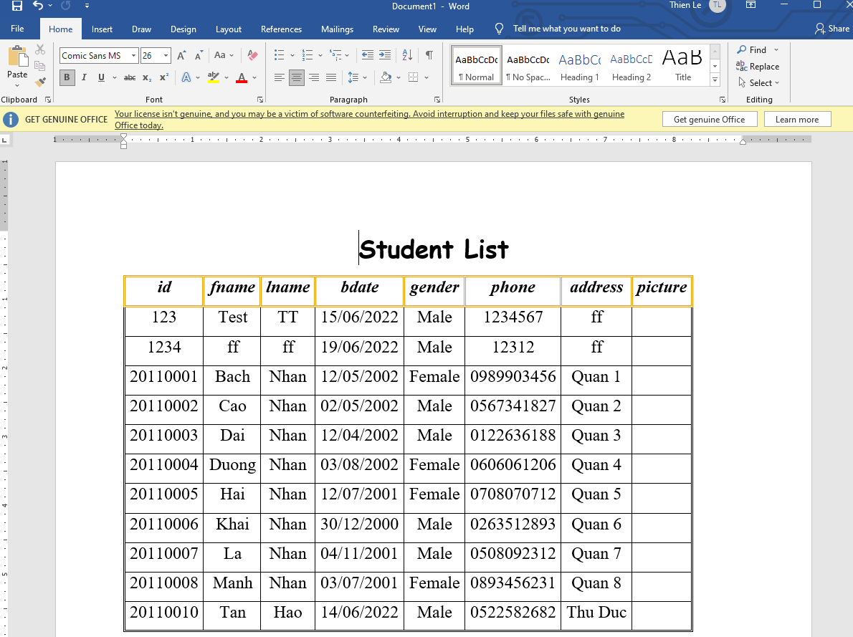

**Print Course**

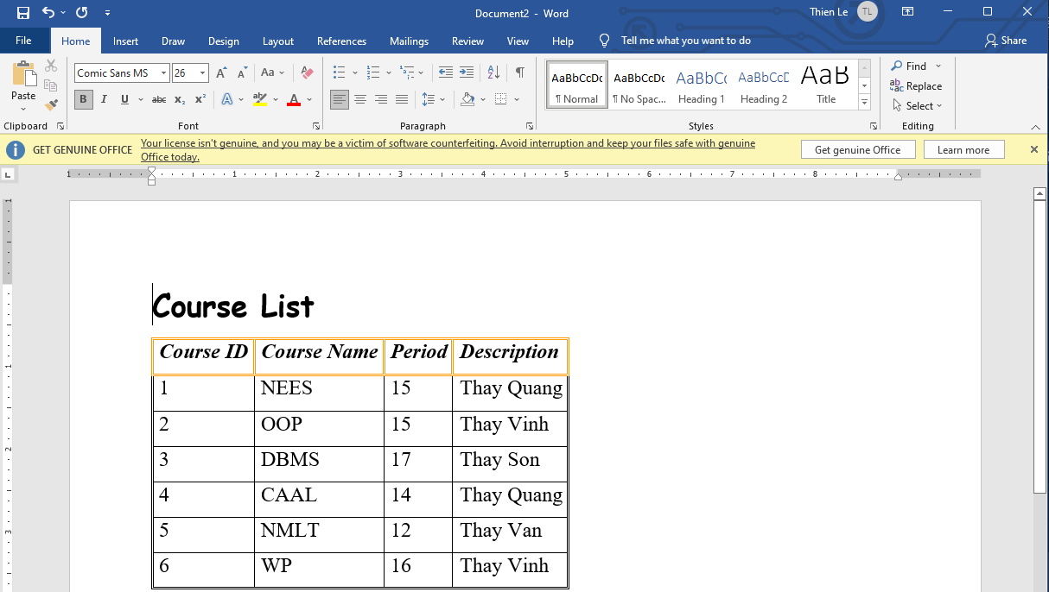

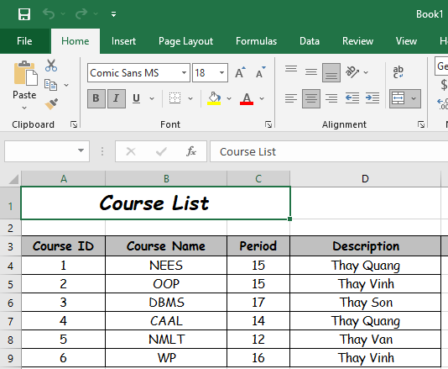

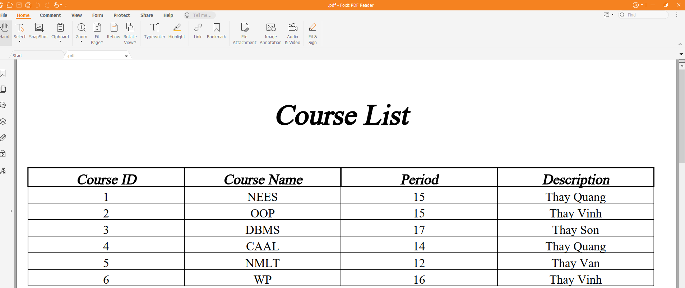

**Print Score**

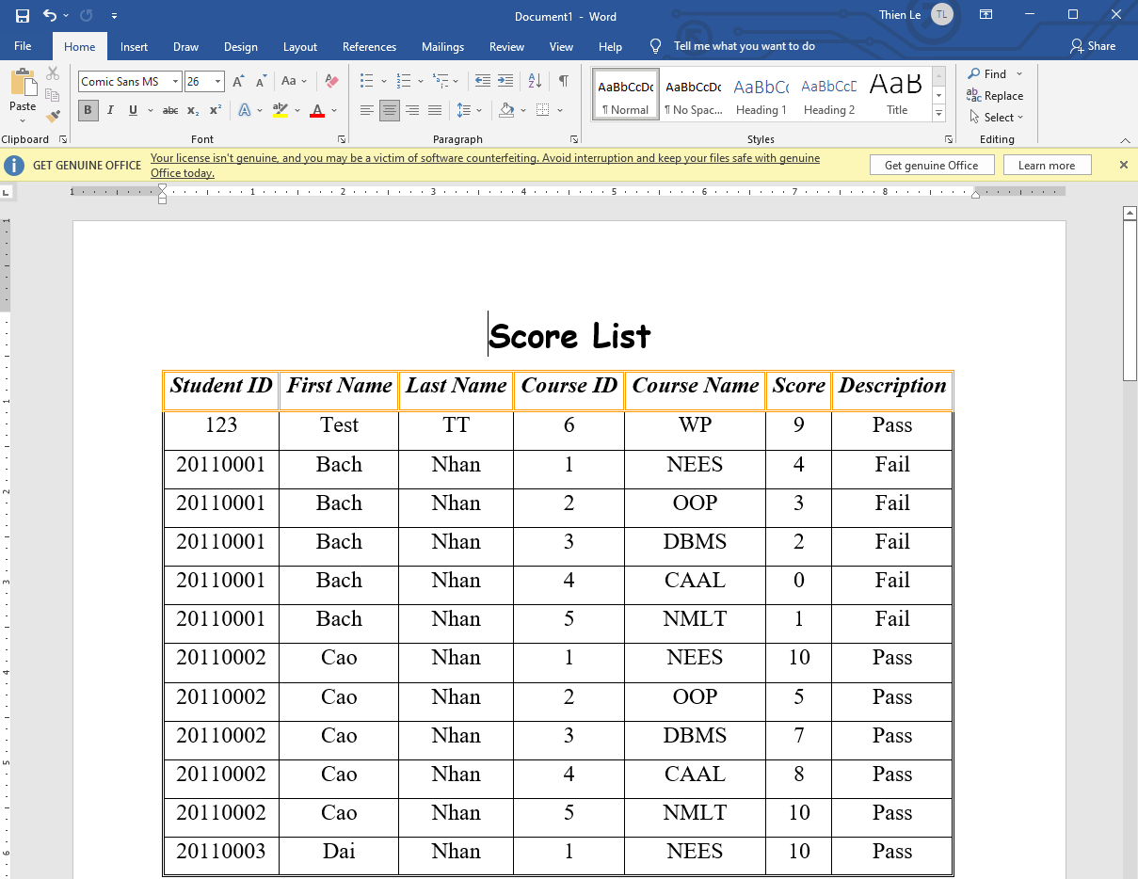

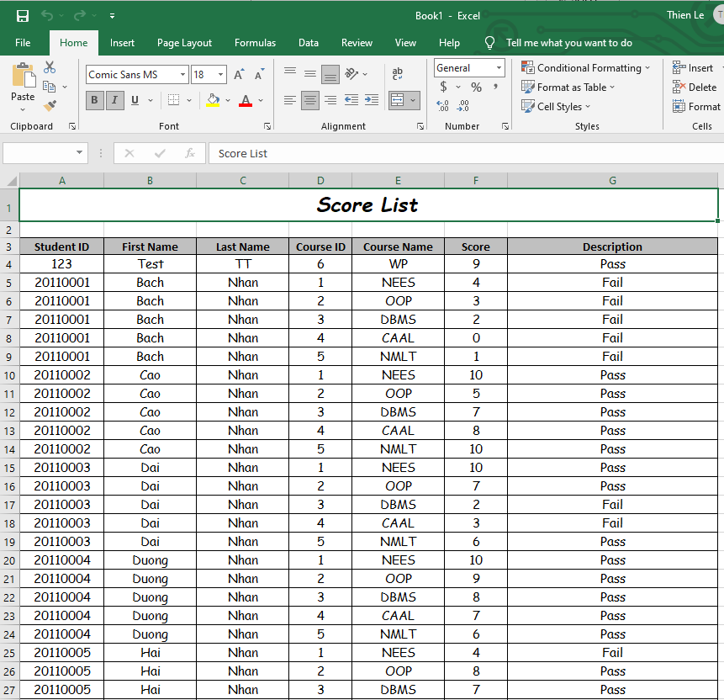

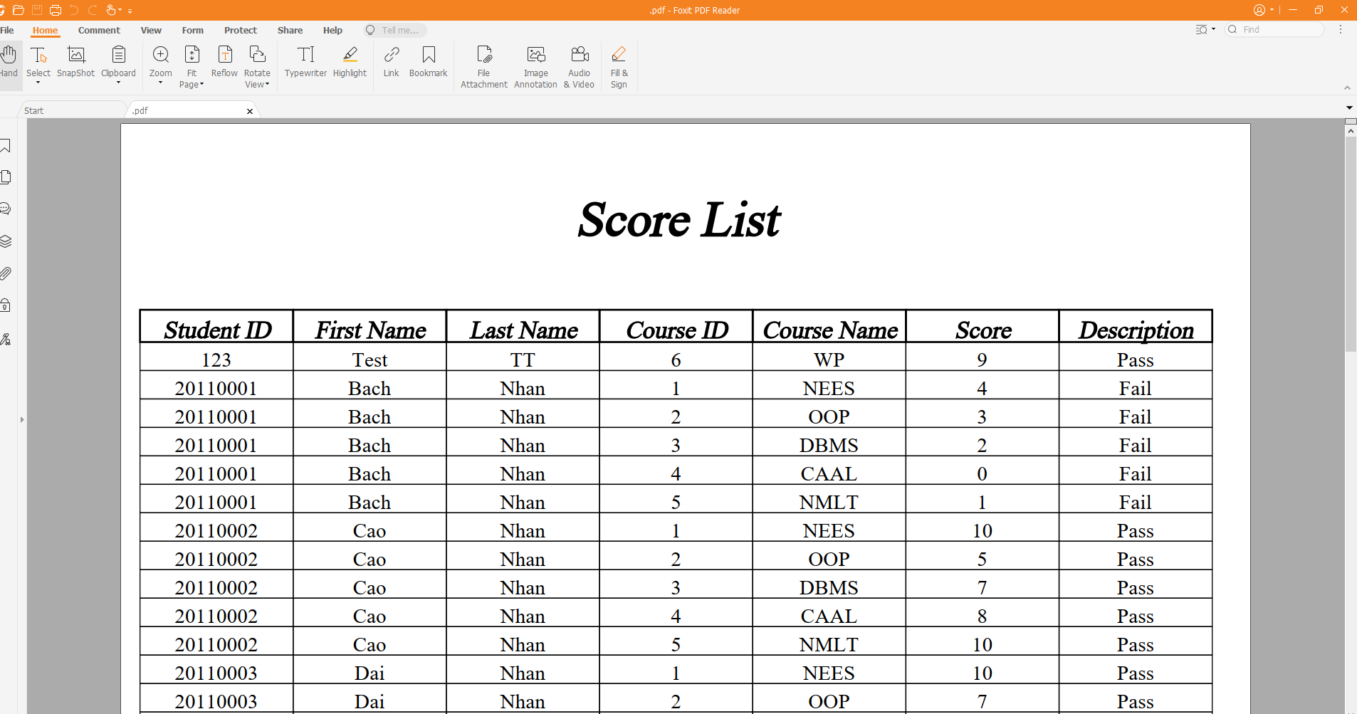

DATABASE DIAGRAMS

Database datagram model

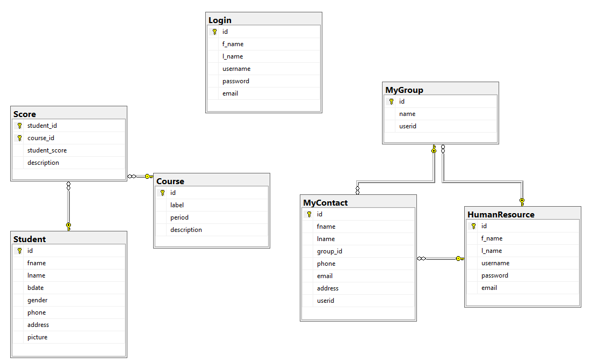

Database table

Table Student

Table Student contain all the basic information of student, id is primary key

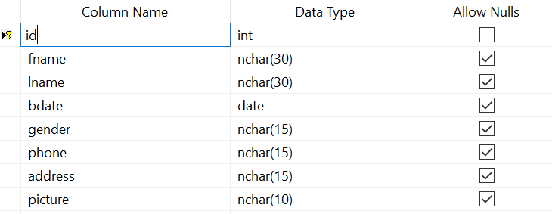

* id: is the id of the student, not allow to null
* fname: is the first name of student, allow to null
* lname: is the last name of student, allow to null
* bdate: is the birth day of student, allow to null
* gender: is the gender of student, allow to null
* phone: is the number phone of student, allow to null
* address: is the address of student, allow to null
* picture: is the image of student, allow to null

Table Course

Table Student contain the information about the course of student, id is primary key

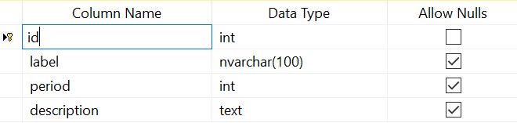

* id: is the id of the course, not allow to null
* label: is the name of the course, allow to null
* period: is the period of the course, allow to null
* description: is the name of the lecture of the course, allow to null

Table Score

Table Score contain the information about the score of course, student_id is foreign key reference to id of table Student, course_id is foreign key reference to id of table Course, student id and course id is primary key

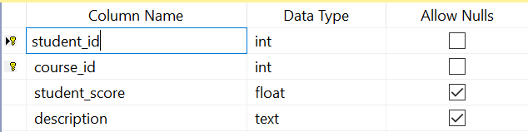

* student_id: is the id of the student who studies the course, not allow to null
* course_id: is the id of the course, not allow to null
* student_score: is the score of the course, allow to null
* description: is the result pass or fail of the course, allow to null

Table Login

Table Login contain the information about the account of the users, id is primary key

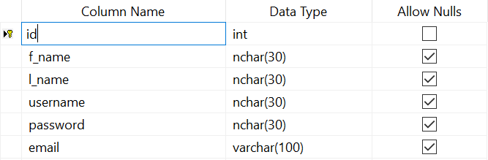

* id: is the id of the user, not allow to null
* f_name: is the first name of the user, allow to null
* l_name: is the last name of the user, allow to null
* username: is the name that user use to login to the account, allow to null
* password: is the password of the account, allow to null
* email: is the email of the user, allow to null

Table HumanResource

Table HumanResource contain the information about the account of the users, id is primary key

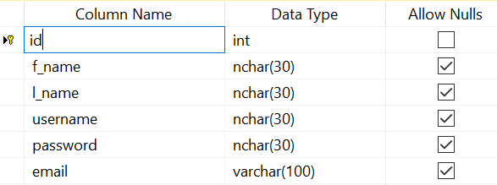

* id: is the id of the user, not allow to null
* f_name: is the first name of the user, allow to null
* l_name: is the last name of the user, allow to null
* username: is the name that user use to login to the account, allow to null
* password: is the password of the account, allow to null
* email: is the email of the user, allow to null

Table MyContact

Table MyContact contain the information about the methods to contact with the teacher, group_id is foreign key reference to id of table MyGroup, userid is foreign key refernce to id of table HumanResource, id is primary key

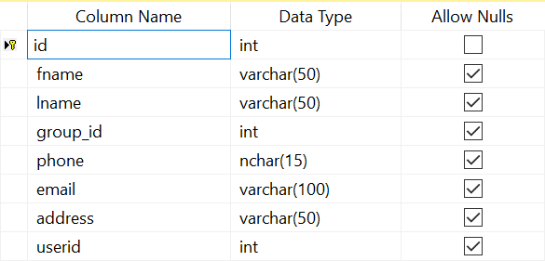

* id: is the id of the user, not allow to null
* fname: is the first name of user, allow to null
* lname: is the last name of user, allow to null
* group_id: is the id of the group of user, allow to null
* phone: is the number phone of user, allow to null
* email: is the email of the user, allow to null
* address: is the address of user, allow to null
* userid: is the id of the user, allow to null

Table MyGroup

Table MyGroup contain the information about the group of the users, userid is foreign key reference to id of table HumanResource, id is primary key

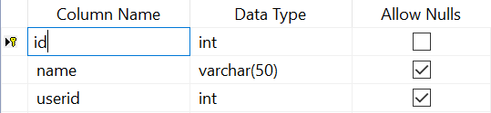

* id: is the id of the user, not allow to null
* name: is the name of user, allow to null
* userid: is the id of the user, allow to null

SOFTWARE ARCHITECTURE

Database Tier: Dbmain

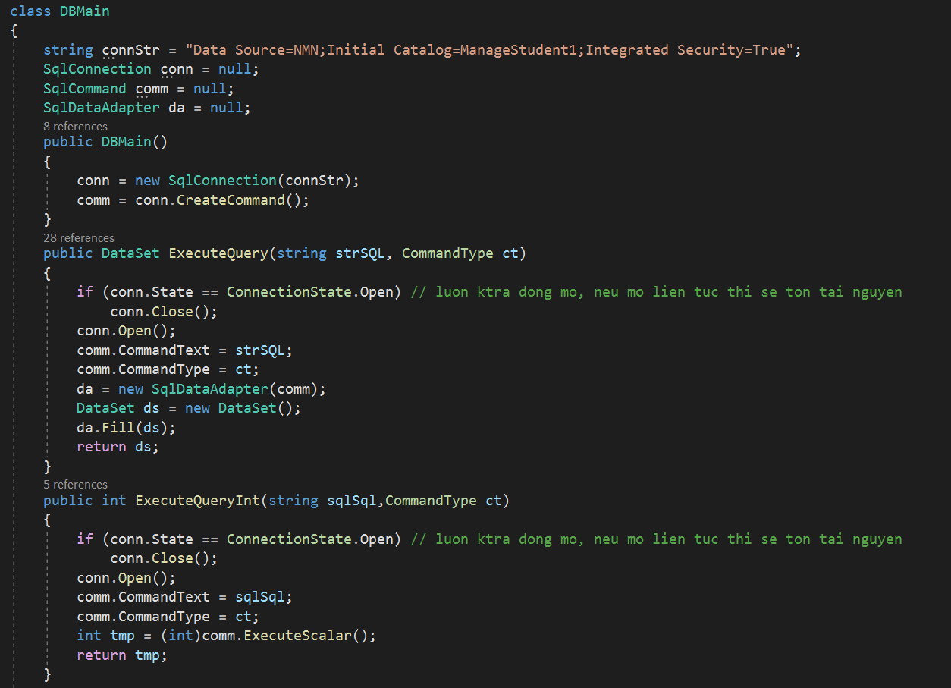

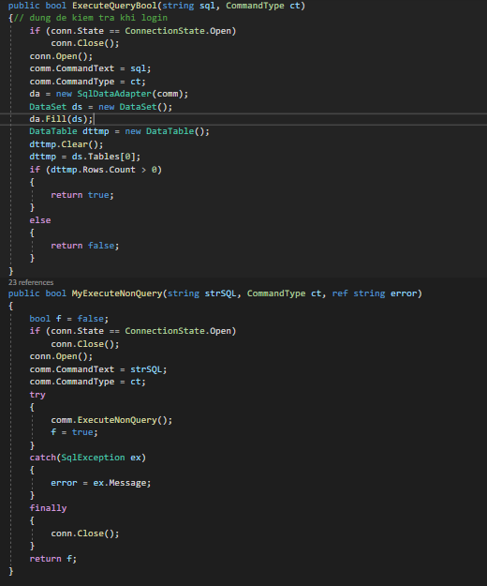

This class used to manage connection with database and those function used in the second tier.

Business Tier

Includes: BLStudent, BLCourse, BLScore, BLResult, MyContact, Group, HrLogin, AccountLogin, Global, StudentExport, CourseExport, ScoreExport.

**BLStudent**

This class is used to support for forms which is used to manage the basic information of student.

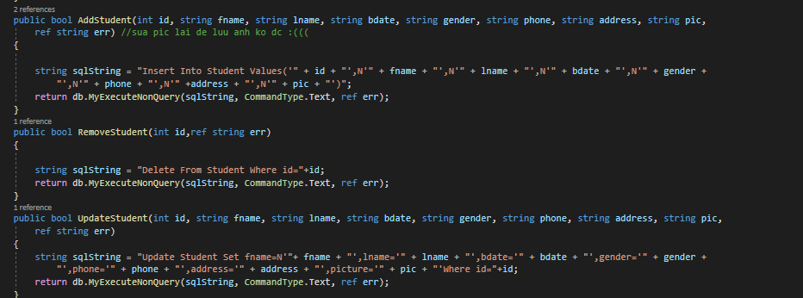

This is the basic operation use to management student

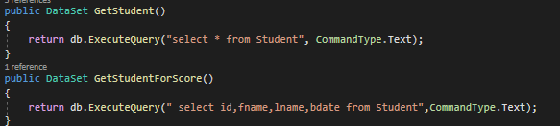

This use to get the data of student with 2 types

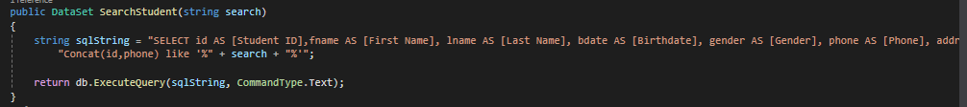

This use to support search feature

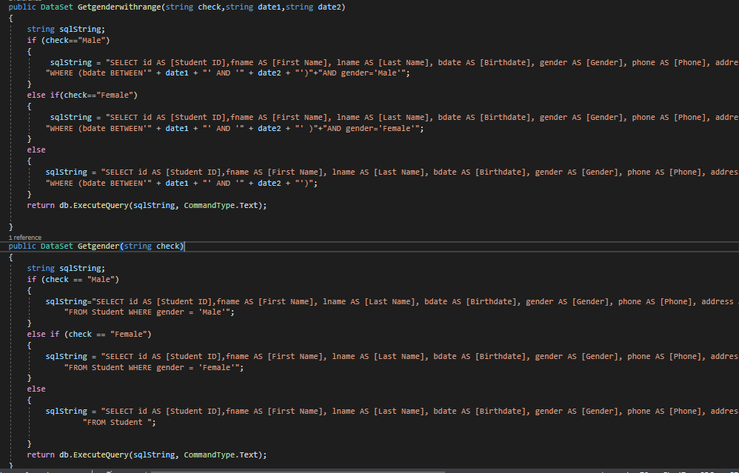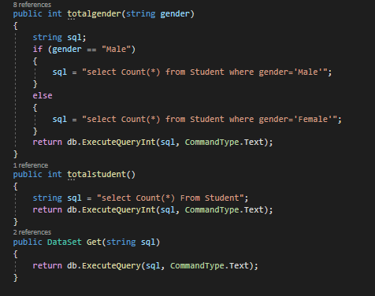

This operation use to get data and calculate information support for statistic gender

**BLCourse**

This class is used to support for forms which is used to manage the basic information of Course

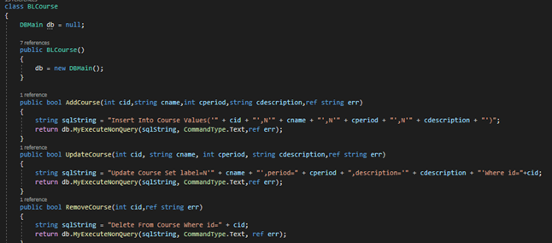

This is the basic operation use to management student

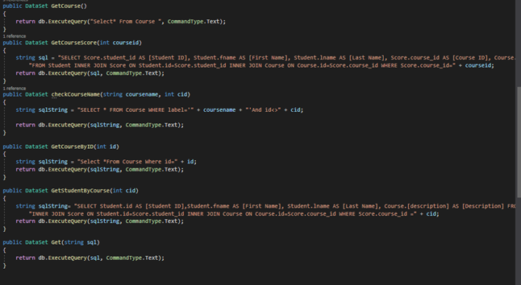

This use to get the data of Course with different methods

**BLScore**

This class is used to support for forms which is used to manage the basic information of Score

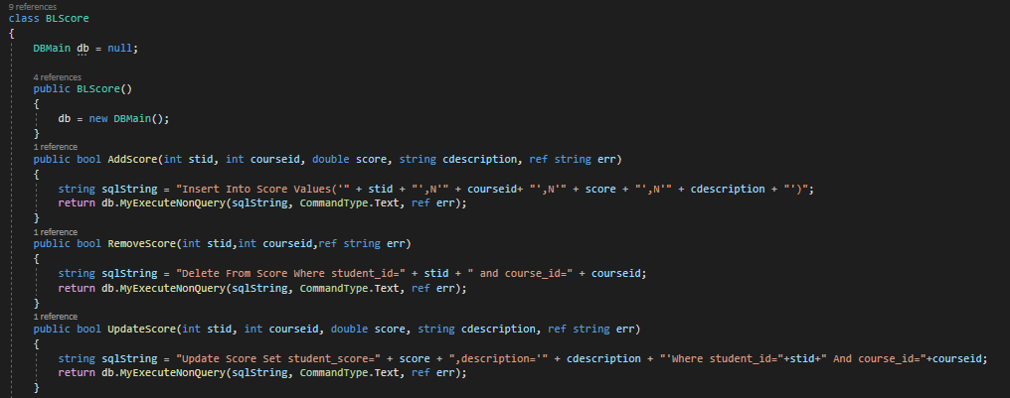

This is the basic operation use to management Score

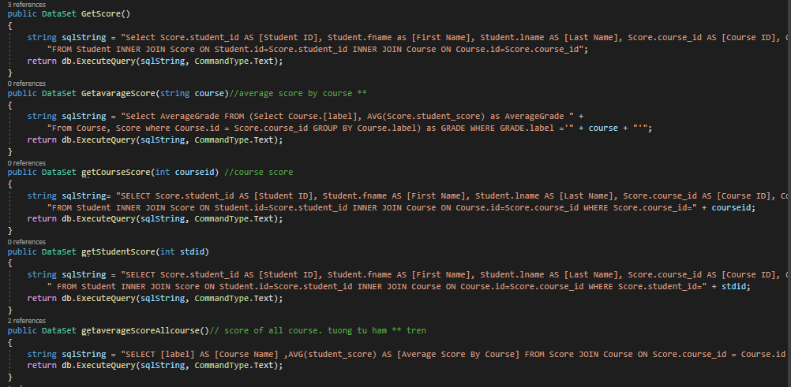

This use to get the data of Course with different methods

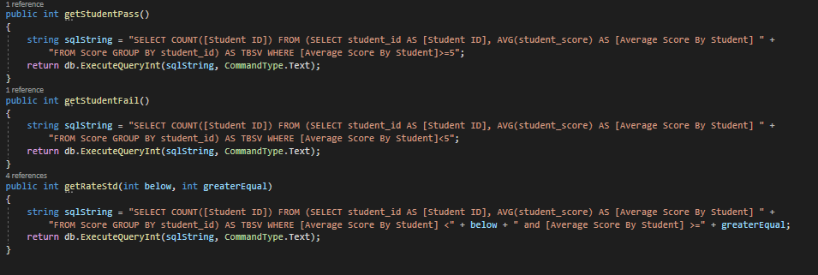

This use to calculate the average score of student and support to statistic result of student

**BLResult**

This class is used to support for forms which is used to show the result of Student

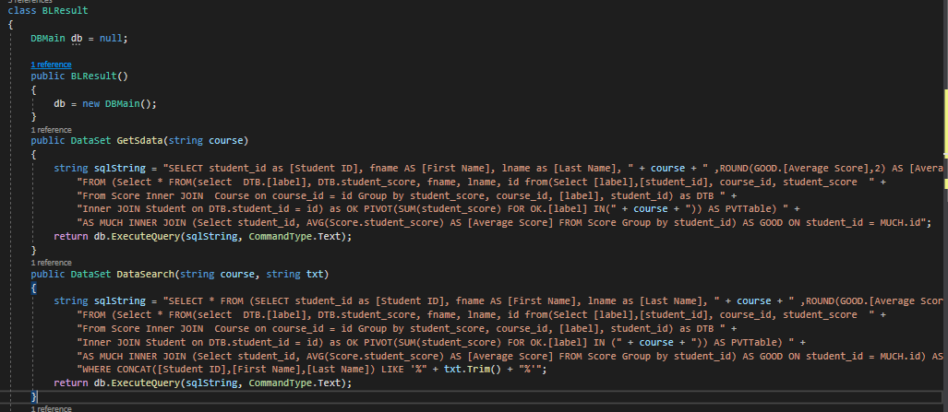

This use to show the result of student and support for search student operation in Result Interface

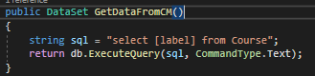

This use to get the name of course which student study

**Group**

This class is used to support for forms which is used to manage the basic information of Group

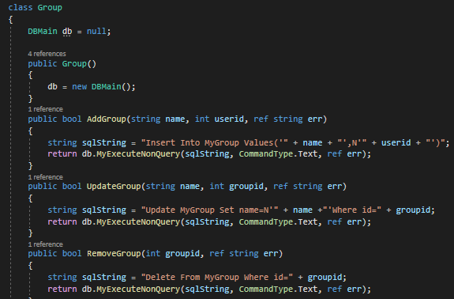

This is the basic operation use to management Group

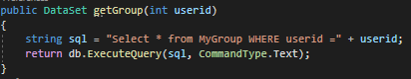

This use to get the data of group base on *userid*

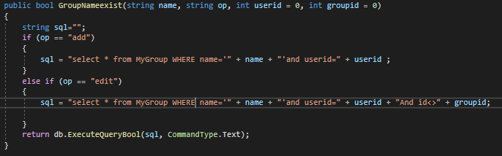

This use to check name of group whether exist or not when performing basic operation (Add, Edit)

**Global**

This class is used to assign the value when user login that support to HumanResource

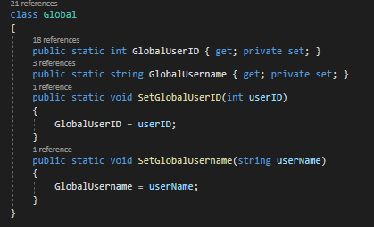

**MyContact**

This class is used to support for forms which is used to manage the basic information of MyContact

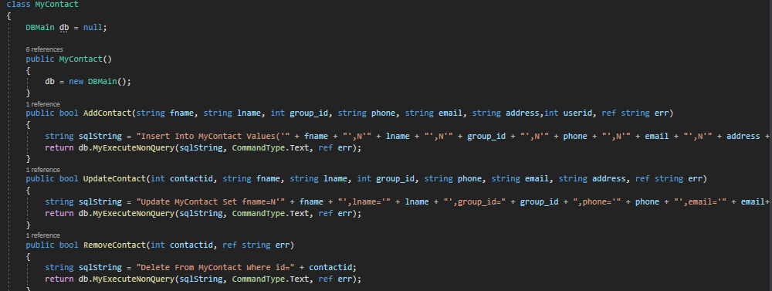

This is the basic operation use to management MyContact



This use to get the data of MyContact base on *contactid*

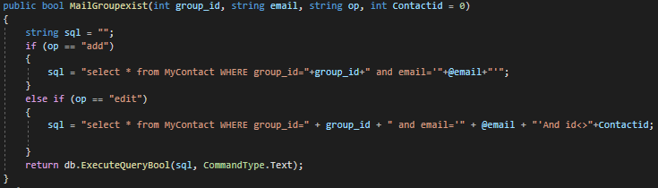

This use to check email of Group whether exist or not when performing basic operation (Add, Edit)

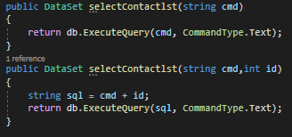

This use to support get the list of Contact

**AccountLogin**

This class is used to support for forms which is used to manage the basic information of account when user login with purpose manage student

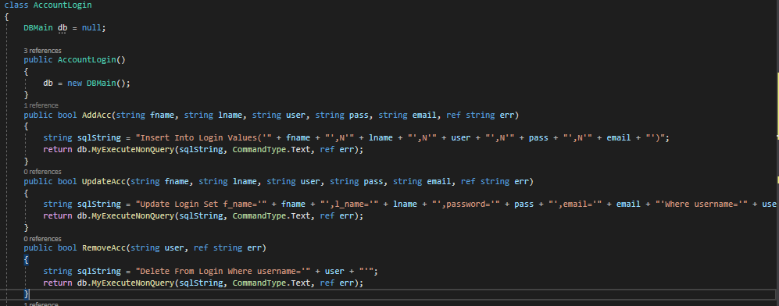

This is the basic operation use to management AccountLogin

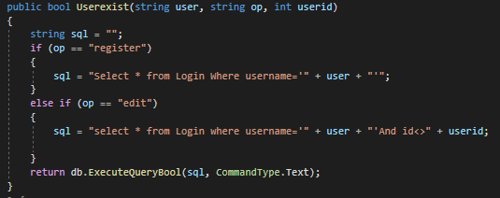

This use to check the information whether exist or not when performing basic operation (Add, Edit)

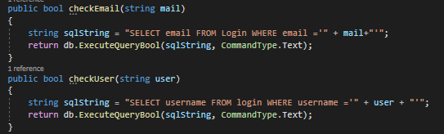

This use to check the information when user register or forgot password

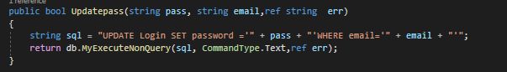

This use to update password for user

**HrLogin**

This class is used to support for forms which is used to manage the basic information of account when user login with purpose management *group* or *contact*

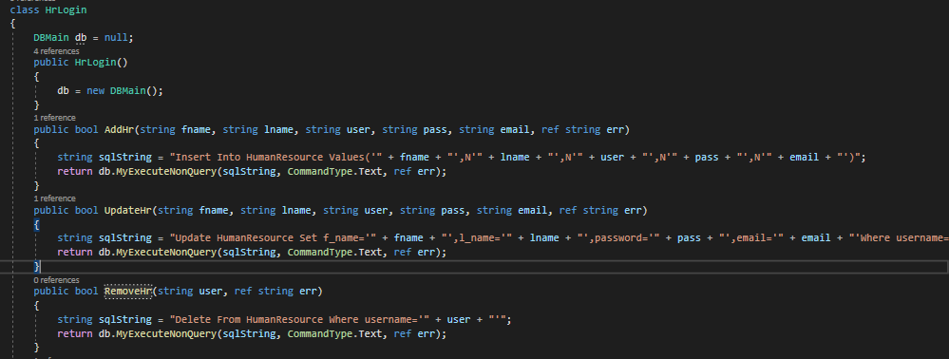

This is the basic operation use to management HumanResource

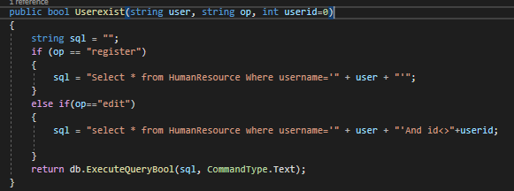

This use to check the information whether exist or not when performing basic operation (Add, Edit)

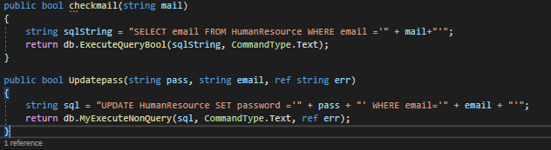

This use to check the information when user register or forgot password and update password for user

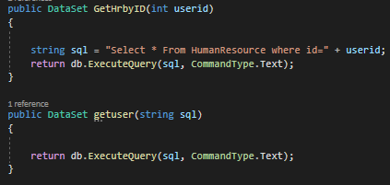

This use to get the information of user.

**StudentExport, CourseExport, ScoreExport**

Those class use to support export file word, excel or pdf from datagridview

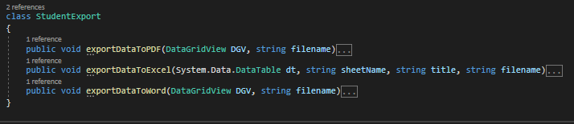

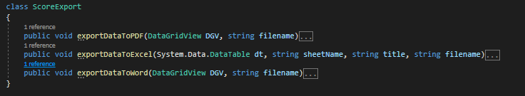 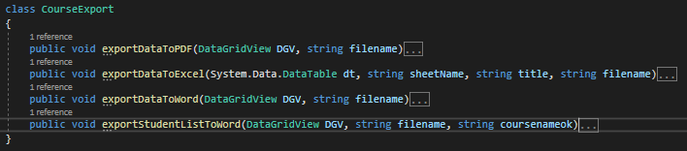

ASSESSMENT OF THE PROGRAM

Advantage

Easy to upgrade, update and change due to its 3-layer design.

The system ensures basic security, specifically some important functions, affecting the system only management staff can use.

Easy to use intuitive interface.

No more basic errors.

Easily list the student, course, score

Disadvantage

Simple database.

Some features are not close to reality

There is still some unprocessed information

OVERALL

Through this course, by designing a program, we have understood well how through the process to make a complete software, also learned how to work in a team, improve programming thinking in addition.

The software is sketchy and has many shortcomings. We would like to thank our teachers for their guidance, comments and evaluations to help us complete this software!